Objective Background:
- Helping those with lowered key pinch strength to be able to play the guitar
- What is Key Pinch strength:
- Examples of who it affects “and many more…”
- Constraint (Is it the minimum force to press on a string?)
- Basic terms for guitar?
  - Neck
  - String
  - Fret
  - Pluck
  - Strum
  - Note
  - Chord
Concept:
- Name ideas:
  - MAK-Digital Guitar
  - Malek Guitar
  - MK Guitar
  - LMN Juitar
  - Digital Guitar
  - Accessible Digital Guitar
- What does it do?
  - Measures and sense what notes and chords you want to play through the strings, and plays the digital equivalent through a midi library
  - This allows the strings to be in low tension and be easier to play since the sound is reliant on them.
- How does it work?
  - Relies on two sets of sensors to know what note or notes you want to play: One that measures which string and fret you are pressing with your fretting hand 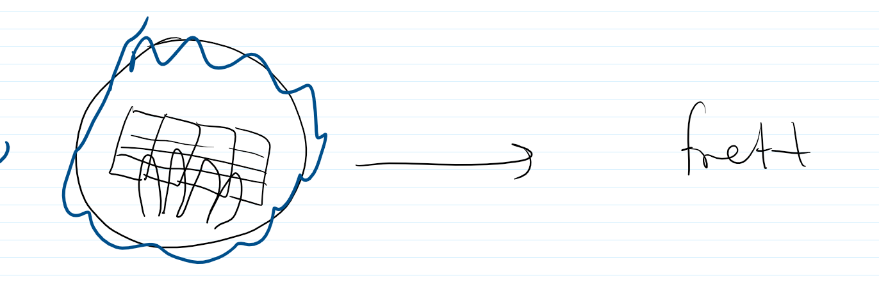
  - And one that measures which string you are plucking or strumming
  - 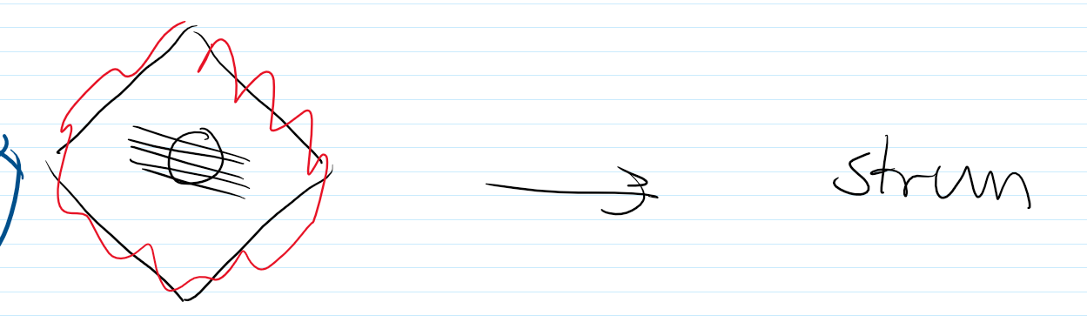
  - Together this information is formed in a computer inside the guitar, powered by a battery
Design Details:
- Strum sensor uses a strain gauge sensor: It measures when the string is put under strain like when being plucked or strummed. This sends an electrical signal to the computer to form the first half of the data required
- The Fret sensor uses Piezoelectric tensile sensors placed along the neck of the guitar. This thin sensor sends an electrical signal only when the circuit is completed by pressing down on the neck. This electrical signal makes up the 2nd half the information required to play a note
- The strings will be low gauge nylon strings in low tension so that they are easy to press down. (Calculations about how much force would be required) (Research about low gauge strings) (Research about Nylon vs steel?).

Stuff to do for poster:
- Find missing research
- Develop symbols for components
- Develop symbols for requirements (Key Pinch and Note/Chord/Key)
- Calculate supposed tension on string and how much it would take to press down

